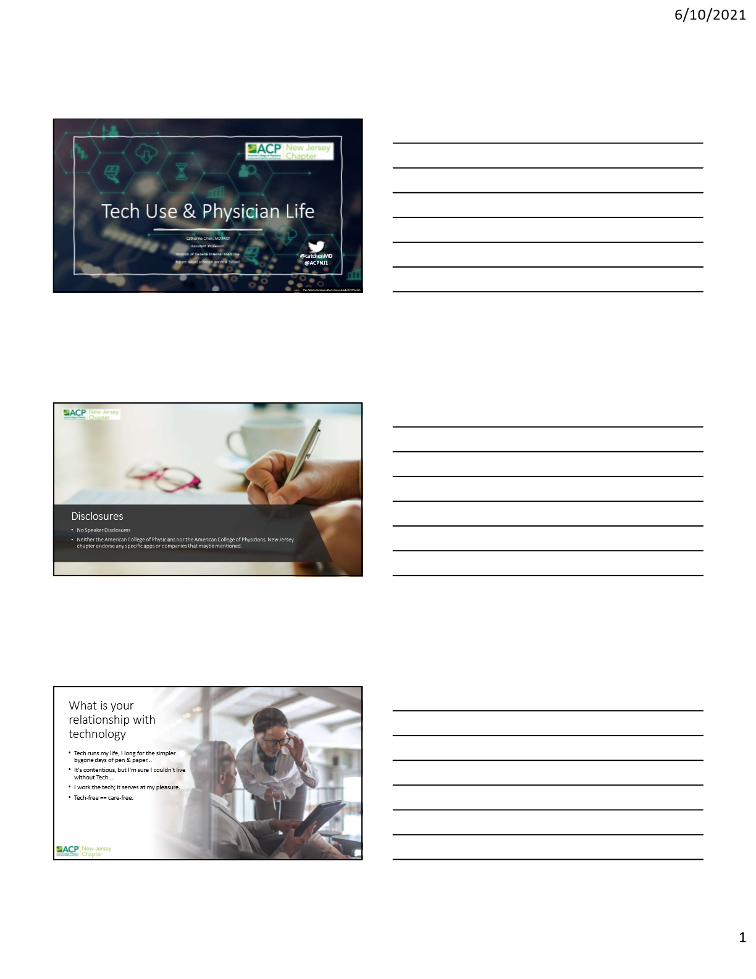

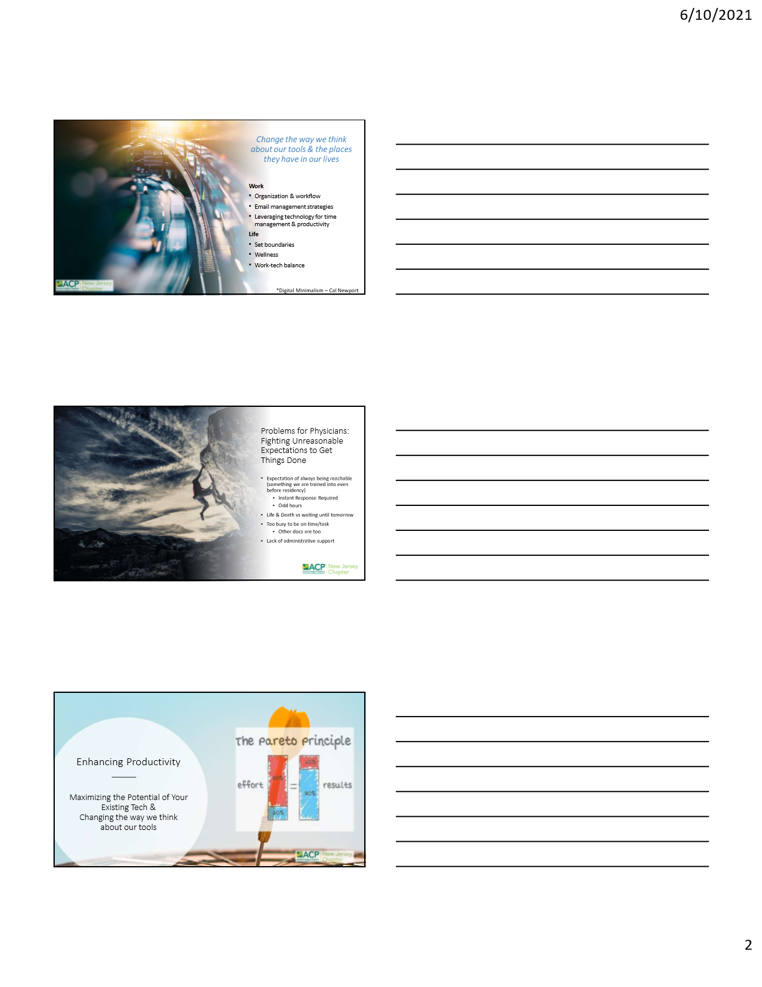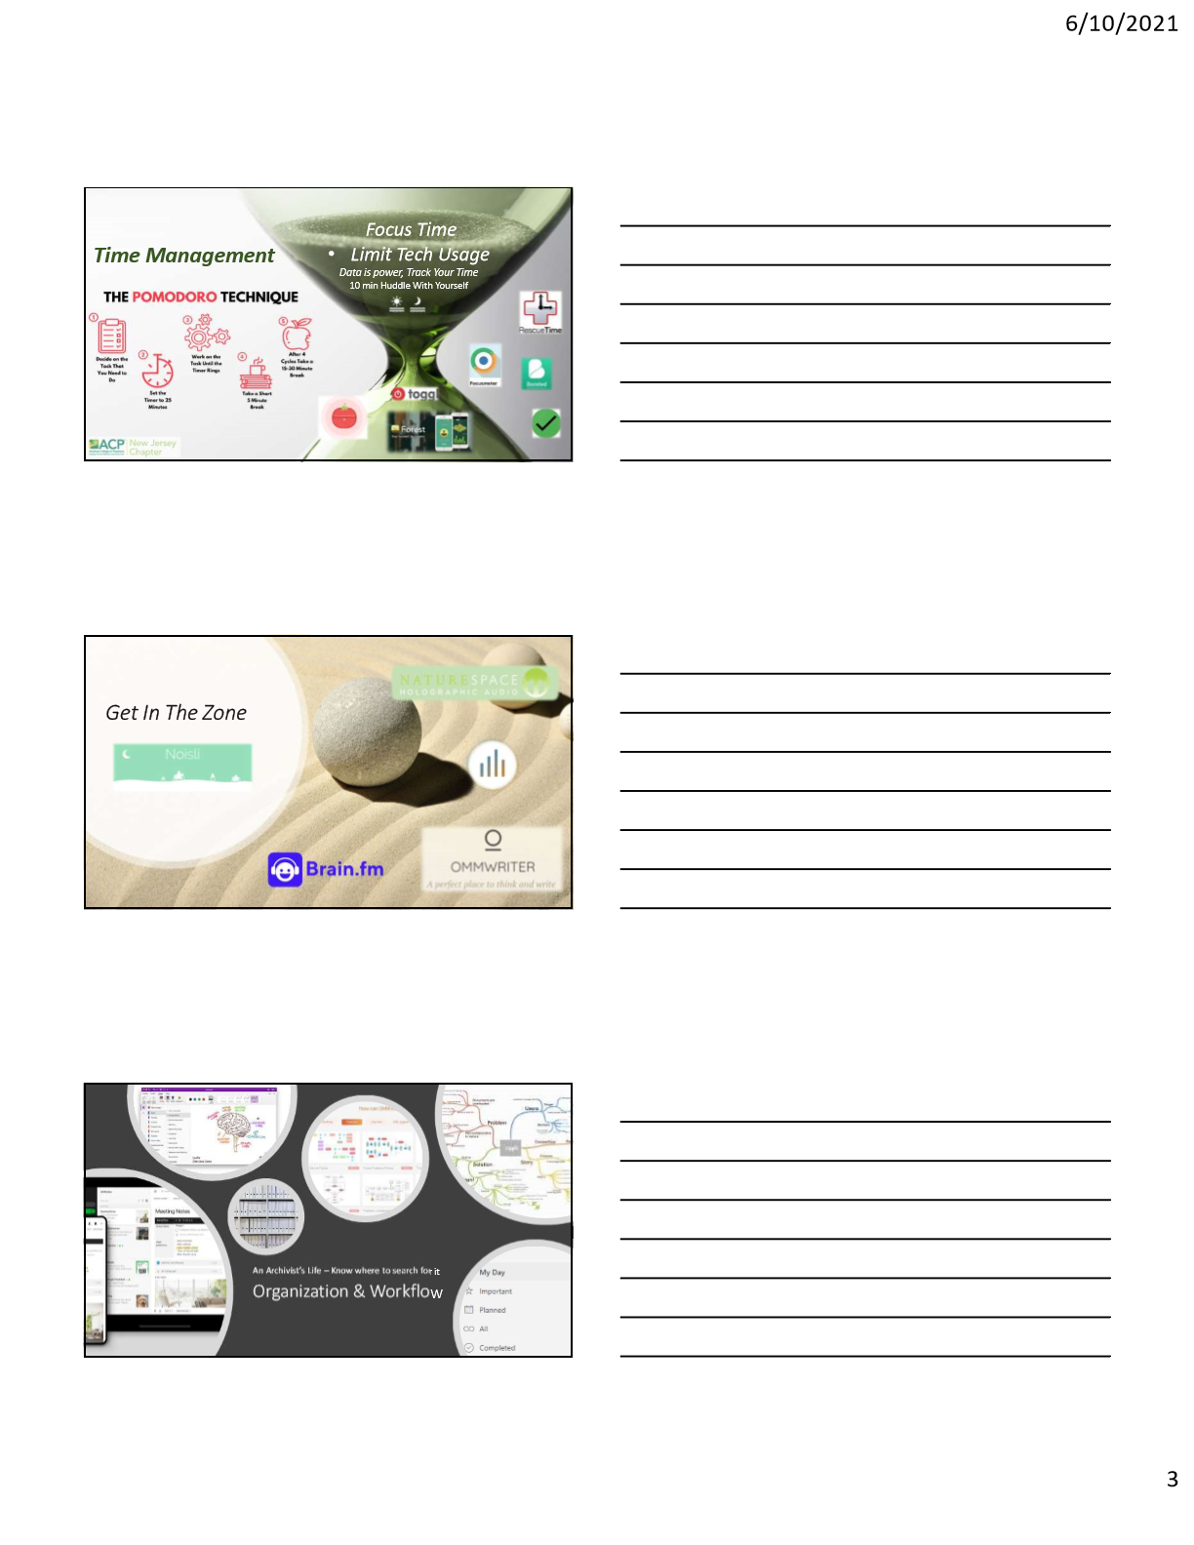

* Store your ideas, Organize thoughts
* Cloud Storage
  + OneDrive
  + OneNote
  + EverNote
* Mind Mapping / Brian Dump
  + GitMind
  + Coggle
  + <https://www.noisli.com/>
  + <http://www.naturespace.org/>
  + <https://ommwriter.com/description/>
* Forest Plants real trees with contributions from your focus time – Trees for the Future <https://www.forestapp.cc/>
* FocusMeter
* Toggl <https://toggl.com/>
* Boosted

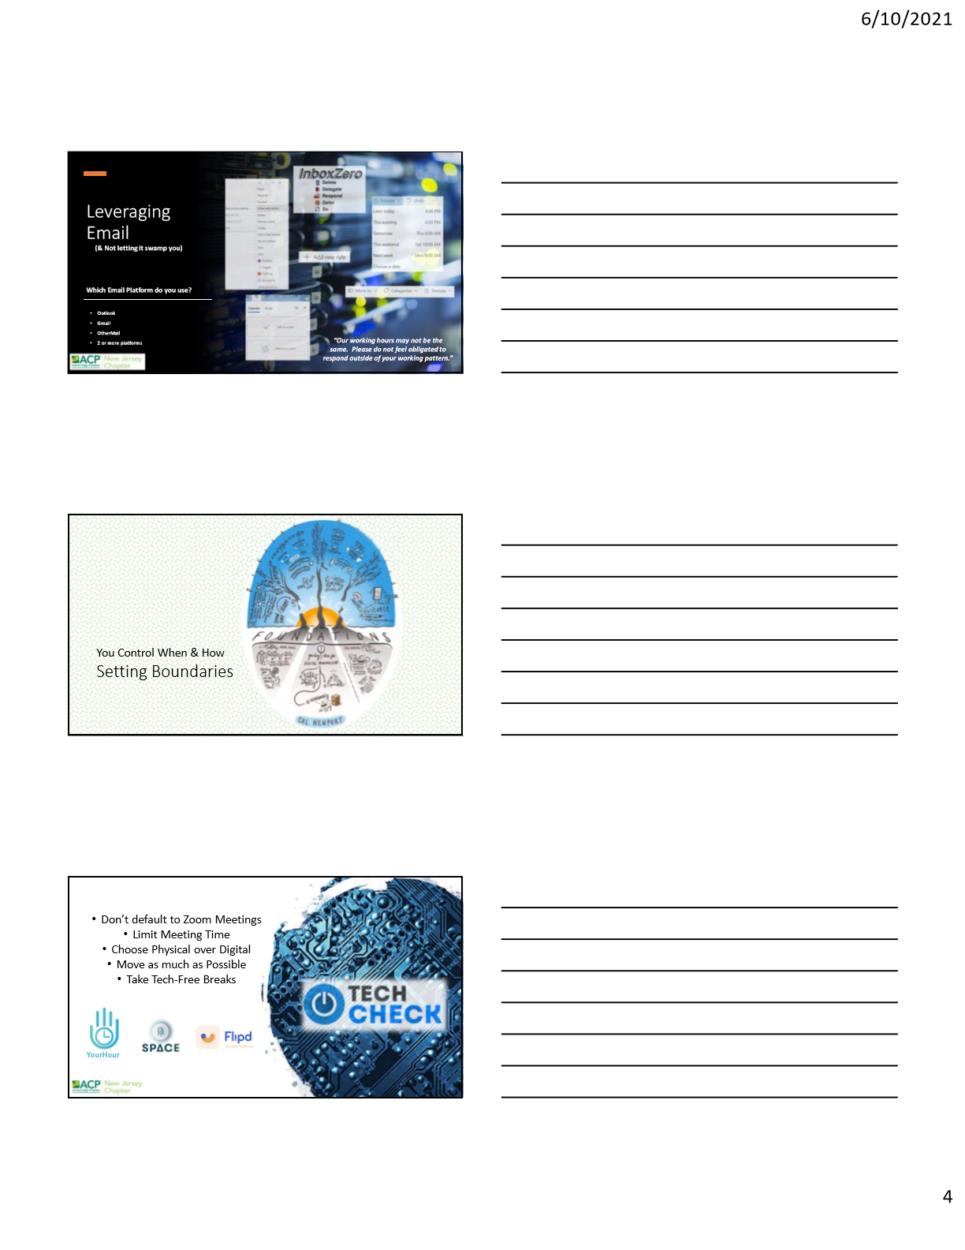

* Work Calendar
* Set up with Google/other Calendar. Share Permissions for ease of scheduling
* Email Optimization
  + “Find Time” / “Reply by Meeting”
  + Out of Office messages
  + “Snooze”
  + Filter / “Create Rule” / Sweep
  + Schedule Sending
  + UNSUBSCRIBE! Aggressively.
  + Add as Task on ToDo
* Digital Declutter, delete apps you never use / apps you do use but wish you didn’t. **Clutter is costly.** This applies to both physical and digital clutter.
* Take a break! Find some activity to replace your tech with.
* 5 min meditation / arts & crafts / garden / cooking?

Bonus: Merlin Bird ID. Picture This - Plant ID

* Host Meetings with Agendas
* Let people go early if it doesn't apply to their work
  + Value their time
* These apps are similar to pomodoro apps

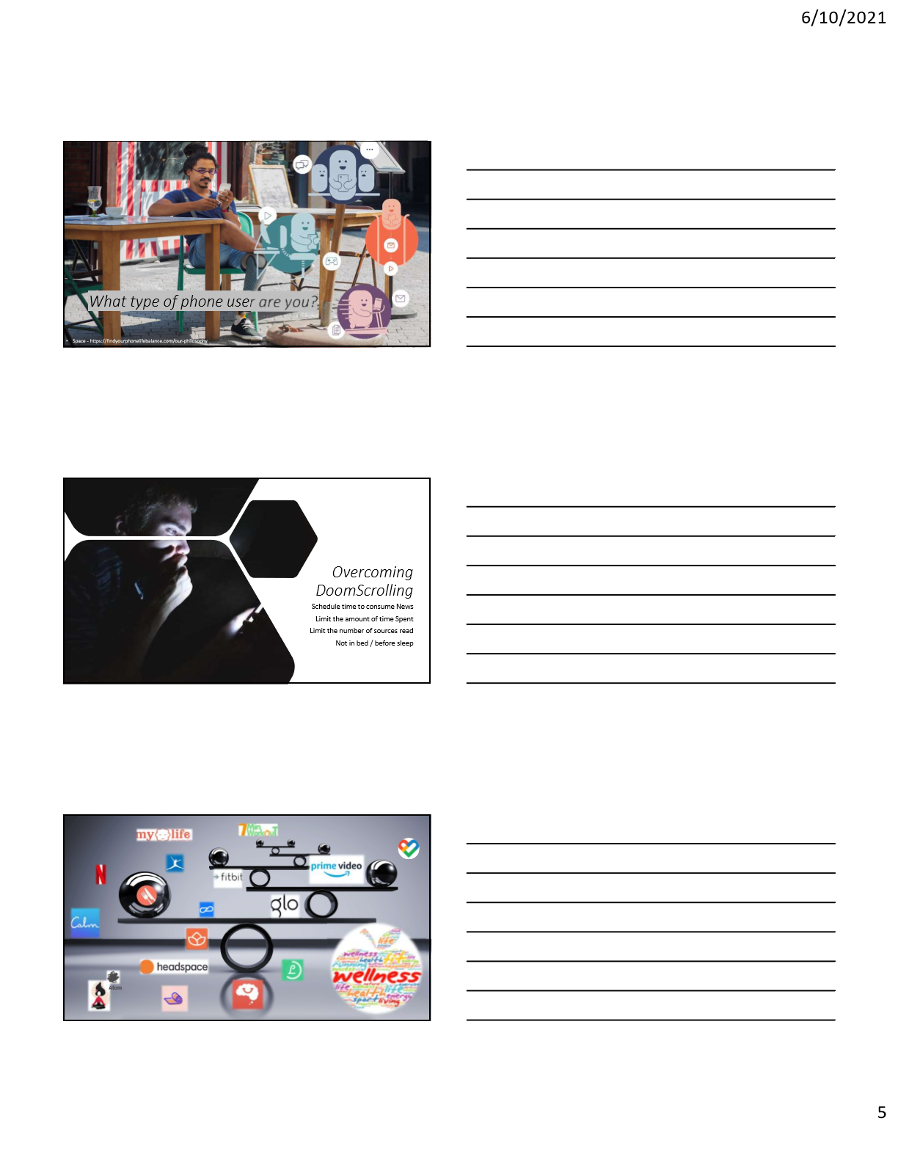

* Nutritional
  + Lifesum
  + MyPlate
  + MyFitnessPal
* Exercise
  + 7-minute workout
  + 30-day fitness challenge
  + Body by Blogilates
  + Track Yoga, Glo
  + Pear Personal Coach
  + Netflix/Amazon/Youtube
  + Activity & Diet trackers
* Meditation
  + Calm
  + MyLife Meditation
  + Headspace
  + Atom
  + Smiling Mind – free

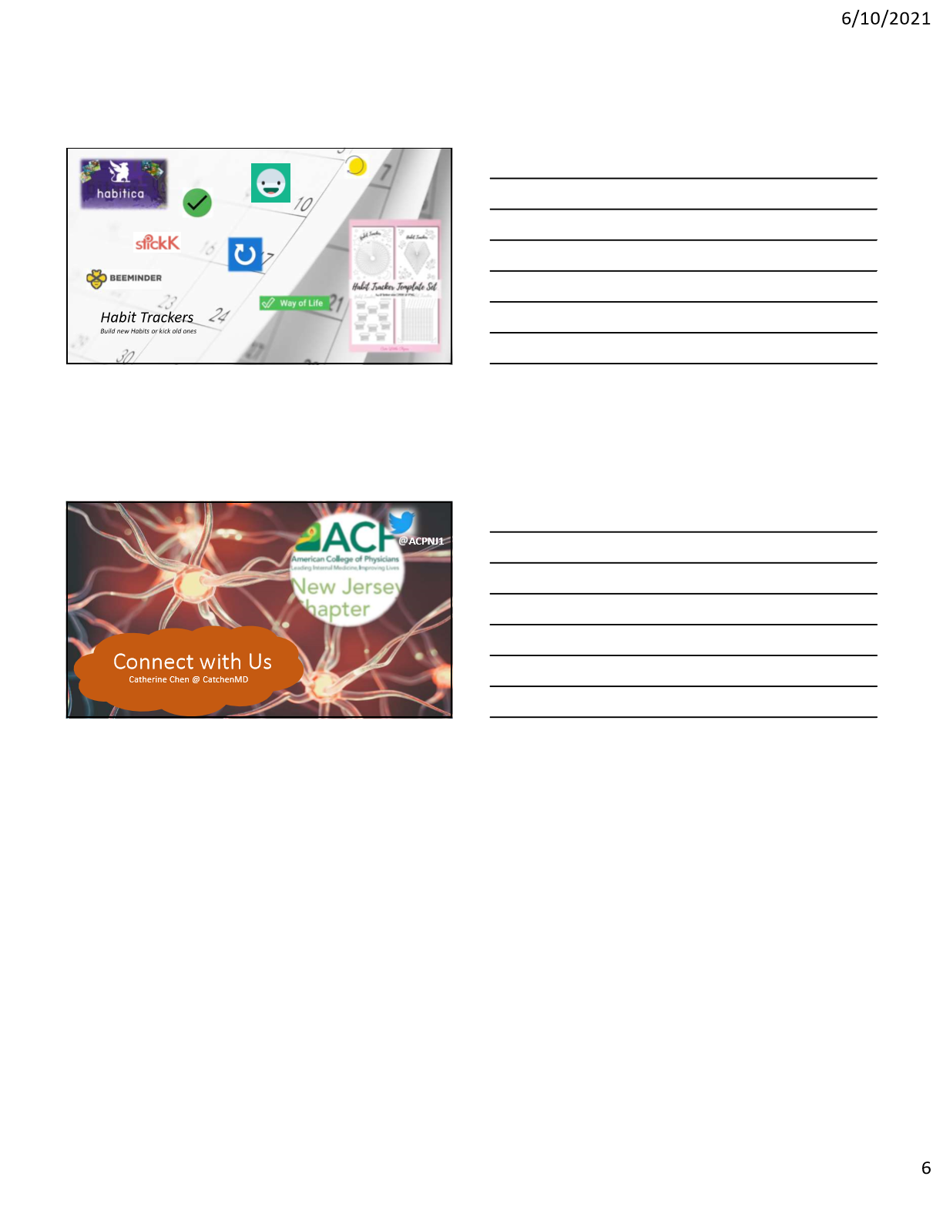

* Habit Trackers or Use the Pomodoro Timer
  + Habitica - Gamefied
  + Way of Life, Loop
  + Routinery
  + Beeminder & Stickk– Pay for getting off track
  + Daylio – mood and habit tracker